A000-China-Hongshan-Jade-Inner Mongolia-Ogniud Banner-Sanxingtala-Boar Dragon-4700-2920 BCE

Fig. 1. China-Hongshan-Jade-Inner Mongolia-Ogniud Banner-Sanxingtala-Boar Dragon-4700-2920 BCE

**Case no.: 5**

**Accession Number: A000**

**Formal Label:** China-Hongshan-Jade-Inner Mongolia-Ogniud Banner-Sanxingtala-Boar Dragon-4700-2920 BCE

**Display Description:**

This elliptical torus, with its blunt snouted head suggestive of the non-domesticated *Sus scrofa* or wild boar, is open at the front with its blunt snout and “tail” opposed to each other. To add motion to this serpentine shape, a flowing mane has been added to the head that us suggestive of an equine. Atlantika Collection.

**This version of a Boar Dragon is a hybrid of an actual animal and its mythic component that reflects the prominent economic and symbolic position of the domesticated wild boar in Hongshan Culture. In this example the prominent jutting boar’s muzzle is thrust forward with a protruding upper lip and a mouth that is firmly closed. The eyes of the boar are pointing forward in an unwavering stare. The mane that is accompanying the boar’s head is swishing in the wind as that of an equine, giving credibility to the motion of the boar dragon as it demands alertness on the part of the viewer. The “C” shaped body recalls the curvature of the smaller so-called “pig dragons” curvature. A small dorsal hole suggests that a sculpture of this size this was meant to be suspended in a sanctuary.**

**In many of the modern descriptions of these so-called “pig dragons” the wild boar origin of the figure is not indicated, and therefore the significance of the domesticated boar for the Hongshan economy is disregarded. An example of this figure was excavated in** Ogniud (Wengniute) Banner-Sanxingtala in 1971.

**LC Classification:** NK5750.2.C6

**Date or Time Horizon:** 4700-2920 BCE

**Geographical Area:** Inner Mongolia-Ogniud (Wengniute) Banner-Sanxingtala

At ca 8,000 BCE four sites in three provinces attest to the beginnings of agriculture identified by excavated domesticated phytoliths paired with solely wild faunal remains (Huang 1966; Yan 1997): Hebei (the Nanzhuangtou site 39° N lat. in Xushui County, Baoding Institute et al. 1992), Hunan (the Yucanyan site in Dao County, 25.5° N lat.) and Jiangxi (Xianrendong and Diaotonghuan 28.5° N lat., Yan 1997, in Wannian County). These sites represent transitional Hunter-gatherer / Neolithic cultures.

At ca 6,000 BCE Asians with the D haplogroup living in the Yangtze River delta domesticated both foxtail millet (Wu et al. 2007) and wild boars. In Hebei (Wu’an County, 36.5° N lat.) at the Cishan site (Jing and Flad 2002) burial pits of domesticated wild boars were overlain by charred, domesticated foxtail millet (Jing and Flad 2002; Jing et al. 2008). Domesticated foxtail millet, a C4 plant that cycles CO2 into four-carbon sugar compounds, is very efficient in hot, dry climates and was an important component of both the human and swine diets (Jing and Flad 2002). The discarded chaff of domesticated cereals appears to have been used to feed wild boars. Domesticated wild boars have been identified by tooth size (lower 3rd molar L41.4, W 18.3), age at slaughter (> 60%, .5-1 yr.) and archaeological context such as ritual burial of entire skeletons beneath charred foxtail millet.

These emergent Neolithic Hongshan people, who secured both economic control over these two inter-related animal and plant food resources and consolidated their political power through manipulation of these resources of productive wealth, were speakers of Altaic, either pre-Mongolic or Korean but not Sinitic (Blench 2004; but see Guo 1995).

By 6000 BCE the Yangtze River delta had emerged as an area of importance for the development of a dual domesticated boar and foxtail millet economy. In order to gain the respect of the masses political élites doled out to the commoners not only grain and pork (Flannery 1968, Bradley 1972, Frankenstein and Rowlands 1978, Kristiansen 1991, Saenz 1991) but also prestige goods such as jade and silk (Firth 1965; Leach 1970:162-63).

Within a Neolithic time-horizon of 6000-2200 BCE a Hongshan Boar Symbolism was developed that was incorporated into jade, clay and wooden objects which were produced by élite artisans supported by the political élites. These artisans developed an iconographic display of power in jade artifacts that was beyond the reach of commoners.



This drawing of a *Sus scrofa* *domesticus* embryo (from Keibel 1897, v. 1, pl. 2, no. 16), with internal organs removed, shows the spinal cord and the cranium which appears to be the basis of the shape of the so called “pig dragons” or porcine symbolism in Hongshan jade art.

**Porcine symbolism was incorporated into the following types of artifacts:**

1). Torus of revolution as a basis for porcine symbolism. Hongshan artisans developed a symbolism using the torus of revolution to symbolize the pig, the most important animal protein resource of their culture. The pig was the domesticated form of the wild boar that had been hunted in the earlier stages of pre-Hongshan culture. These sculptures are the so called “pig dragons” (zhū long, 豬龍) which is the name that the later Han culture termed them, but the non-Sinitic Hongshan name is unknown.

Geometrically, a torus of revolution is a surface generated by revolving a circle in three-dimensional space about an axis coplanar with the circle but does not touch the circle. This results in a donut shape.



Torus of revolution after <https://upload.wikimedia.org/wikipedia/commons/thumb/4/47/Torus.svg/440px-Torus.svg.png>

These tori of revolution range in size from diminutive 1-4 in to larger examples >4 in to 12 in.

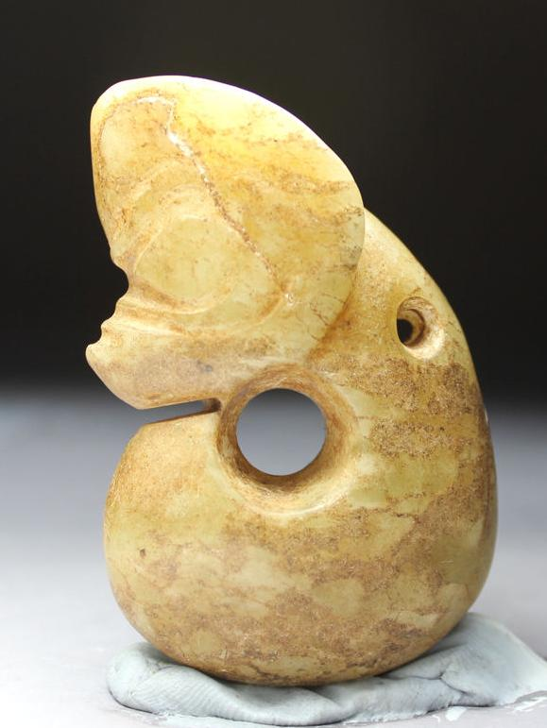

Hongshan-Liaoning-Porcine Torus-Pig Dragon-Jade-4700-2920 BCE -2.4 in. Atlantika collection

This example of a porcine torus has a boar-like snout and pointed ears on an elongated, "suggestively fetal” limbless body, coiled around a central axis. Early Hongshan so-called “pig-dragon” jade carvings (ca 5000 BCE) have stout, pig-like bodies, while later Hongshan examples (ca 3000 BCE) have slender, serpentine bodies. Since “pig-dragon” jade carvings have been excavated as Hongshan grave goods (Howard 2006), and since pig bones have accounted for 60 percent of animal bones recovered from Hongshan sites, it is inferred that pigs were important not only for the Hongshan economy but also for their symbolic significance. The melding of a fetal-serpentine shape with that of a pig may have been intended to couple an ancient dragon-serpentine shape with that of an economic icon producing a powerful Hongshan foundational image.

In contrast to the Graeco-Roman and Judaeo-Christian-Muslim notions of the soul as the essence of a human being, the Hongshan people of ancient China regarded the soul as the source of their material sustenance that is composed of beings, both animal and human, that personify the bodily essence of their native selves.

To the Hongshan people the pre-eminent animal was the wild boar that was originally hunted in the Mulanshan -- mountains of great, natural wilderness. Images of Mulanshan were conceived by Hongshan sculptors of jade, the stone of immortality, as rounded summits with burrows of the wild boar as circular hollows within these mountains. Images of the wild boar were sculpted on the ends of these mountains -- with their hollows -- making the identity of the sculpture explicit. Thus, this entire sculpture – boar, mountain and burrow -- became the emblem of the Hongshan essence of life.

To further exemplify the source of this essence of life, images of the wild boar as a curled-up fetus about to emerge from the womb, were also sculpted from jade. These sculptures ranged in size from personal amulets to large figures hung in ritual sanctuaries. Their presence was intended to recall the time when these wild boars were first captured and then later domesticated for animal husbandry, thereby marking the moment at which the Hongshan culture emerged from its hunting-gathering existence into a Neolithic, sedentary existence capable of creating such provocative reminiscences of the ancient past.

The Hongshan conception of culture and community required that all participate in this memory of the ancient ways of hunters who could assume the personae of the hunted so that the life of their communities could be sustained in an otherwise alien world. To understand the Hongshan self, one needs to be open to assume this shamanic posture of ecstasy, of being able to stand outside of one’s self and to assume the identities of nature -- both wild animals and humans -- without alterity or division. Furthermore, this was a call to assume the blending of souls, the breaking down of one’s ego and one’s acceptance of the Other. Only this opens a window into one’s own identity and alterity, and with it one’s extension of the self into nature, both of animals and humans, where alien types of being and memory can become palpable.

2) Hongshan-Liaoning-Porcine Torus-Pig Dragon-Abstract-Jade-4700-2920 BCE

 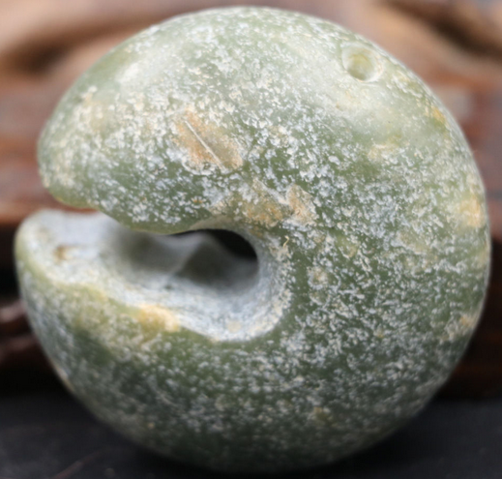 

This example of a porcine torus of revolution (note hole for suspension) has an opening that suggestively shows a boar’s jagged teeth. H 5.4 cm, W 5.4 cm, T 2.4 cm. Atlantika Collection.

3) Hongshan-jade-three-hole, double-boar device-with base tenon-4700-2920 BCE

 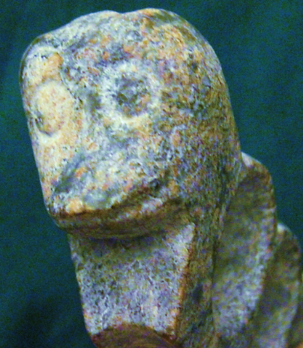

This porcine device has three tori with a suggestive domesticated boar’s head at both ends. The tops of the three tori are considered to be three summits of a mountain range in Liaoning Province that appear like three rounded humps in outline, perhaps home to *Sus scrofa* or wild boar. Atlantika Collection

4) Hongshan-Jade-Porcine Torus-Open-Boar-4700-2920 BCE

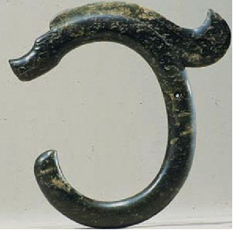

This elliptical porcine torus is open at the front with its “tail” and its blunt snout (suggestively of the non-domesticated *Sus scrofa* or wild boar) are opposed. To add motion to this more serpentine shape, a flowing mane has been added. Atlantika Collection.

**Sheep sculptures as Hongshan Culture Expands Trade and Exchange into Mongolia**

Sheep sculptures were added by artisans to their porcine repertoire as Hongshan trade and exchange with Mongolian sheep herders developed. This suggests increasing cultural complexity and stability, although the degree of complexity and Hongshan connections to other emergent Neolithic cultures in Mongolia and Central Asia are still under debate (Guo 1985).



 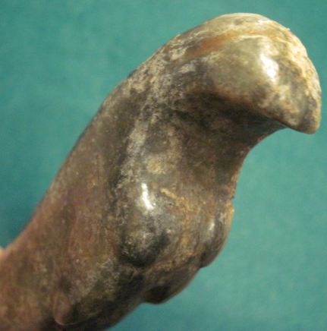

Rare mid-late Hongshan sheep sculpture, ca 2500 BCE, Atlantika Collection

**Climatic fluctuations 4000-2200 BCE**: **development and demise of the Hongshan culture.**

Between 3678-3400 cal. BCE the climate was colder and drier than today. Then, from 3400- 2800 cal. BCE the climate was much warmer and wetter. Between 2800-2300 cal. BCE the climate was persistently cold, with an exceptionally cold event occurring between 2600-2300 cal. BCE. This cold event was recorded at several other localities in Northern China and in the Northern Hemisphere. It played an important role in the emigration of Inner Mongolian people from the Hunshandake Sandy Lands of Inner Mongolia (Yang et al. 2015) to immigrate to the Yangtze River delta and in turn they forced the Hongshan people to emigrate to Taiwan by 2200 BCE, a date that corresponds to the demise of the Hongshan culture which has been an enigma until now (Jin and Liu. 2002).



Map showing location of Hunshandake Sandy Lands outlined in black.

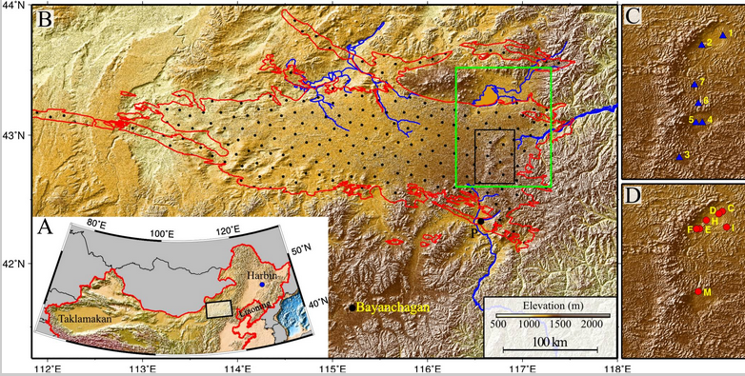

Geographical location of the Hunshandake Sandy Lands (A) and its area (encompassed by red line in B).

The black rectangle in B marks the location of the enlarged maps C and D on the Right, and the green rectangle shows the location of [Fig. 2](https://www.ncbi.nlm.nih.gov/pmc/articles/PMC4311860/figure/fig02/). Map C shows the localities of water samples, and map D shows the localities of stratigraphy The sand–paleosol section P ([Fig. 3](https://www.ncbi.nlm.nih.gov/pmc/articles/PMC4311860/figure/fig03/)) is on the southern margin, and the site Bayanchagan marks the coring site to sample the paleosols (Jiang et al. 2006). Rivers with headwaters in the Hunshandake likely formed by groundwater sapping are marked in blue. Drainages to the southwest and west are currently undergoing groundwater sapping, with substantial spring-driven flow found at the current river base level. From <https://www.ncbi.nlm.nih.gov/pmc/articles/PMC4311860/figure/fig01/>

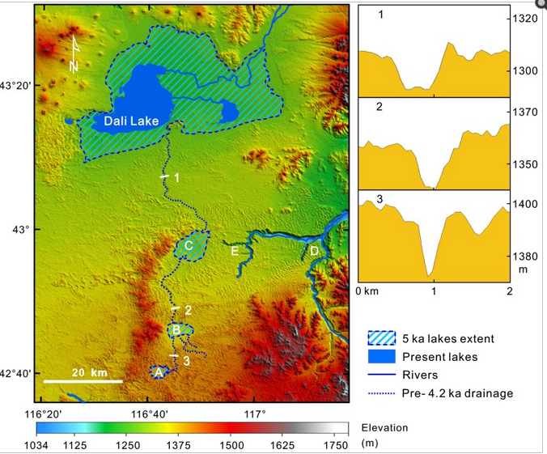

Map of the desiccation of Holocene lakes and channels in the Hunshandake Sandy Lands at selected epochs (Yang *et al*. 2015). Upper, middle, and lower lakes are indicated by points A, B, and C, respectively. Xilamulun River (point D) drains to the east. Groundwater-sapping headcuts at the upper reaches of incised canyons (point E) suggest a mid-Holocene interval of easterly surface flow, followed by groundwater drainage beginning at the ca. 4.2 ka event. Northern and central channels at point E are currently abandoned, and groundwater sapping has migrated to the southerly of the three channels shown. (Right) Cross-sections of the predrainage shift, northerly drainage into Dali Lake (Localities shown on the Left), showing the increase in widths of channels downstream (Vertical exaggeration ∼30:1).

**References**

Anderson, E. N., JR. I988. *The food of China.* New Haven: Yale University Press.

Blench, Roger. 2004. “Human migrations in continental East Asia and Taiwan: genetic, linguistic and archaeological evidence. Université de Genève” [DRAFT CIRCULATED FOR COMMENT]

Chang K. C. I977. *Food in Chinese culture*. New Haven: Yale University Press.

1986. 4th edition. *The archaeology of ancient China*. New Haven: Yale University Press.

1989. "Ancient China and its anthropological significance." In *Archaeological thought in America*. Edited by C. C. Lamberg-Karlovsky, pp. I 55-66. Cambridge: Cambridge University Press.

Childs-Johnson, Elizabeth (1991). "Jades of the Hongshan culture: the dragon and fertility cult worship," Arts asiatiques, **46**: 82–95.

Cohen, M. N., and G. J. Armelagos.1. *Paleopathology at the origins of agriculture*. Orlando: Academic Press.

Freid, M. H. I967. The evolution of political society. New York: Random House.

Freidman, J., and M. J. Rowlands. I978. "Notes towards an epigenetic model of 'civilization,"' in *The evolution of social system*. Edited by J. Friedman and M. Rowlands, pp. 20I-76. London: Duckworth.

Gao, G. I978. “Dawenkou culture its nature and chronology” (大汶口文化的性质和年代), *Kuangmingribao*, April 27.

Guo, Da-Shun 1995. Hongshan and related cultures. In: *The archaeology of Northeast China: beyond the Great Wall.* Nelson, Sarah M. ed. 21-64. London and New York: Routledge.

Guo D. *Hongshan Culture(红山文化*). Artifacts Press; Beijing: 1985.

Jiang W, et al. 2006. Reconstruction of climate and vegetation changes of Lake Bayanchagan (Inner Mongolia): Holocene variability of the East Asian monsoon. Quat Res. 65(3):411–420.

Jin, G. and Liu, D. 2002. Mid-Holocene climate change in North China, and the effect on cultural development. *Chinese Science Bulletin*, *47*(5), pp.408-413.

Jing Y, Flad R. 2002.” Pig domestication in ancient China,”. Antiquity 76: 724–732.

Jing Y, Jianlin H, Blench R. 2008. “Livestock in ancient China: an archaeo-zoological perspective.” In: Sanchez-Mazas A, Blench RM, Ross M, eds. Human Migrations in Continental East Asia and Taiwan. Genetic, Linguistic and Archaeological Evidence. Routledge; Abingdon: New York.

Johnson, A. W., and T. Earle I987. *The evolution of human society: From foraging group to agrarian state*. Stanford: Stanford University Press.

Keibel F. 1897. *Normentafeln zur Entwicklungsgeschichte der Wirbelthiere*, (*Sus scrofa domesticus*). Bd. 1. Jena: Fisher, v. 1, pl. 2, no. 16.

Kaogu. I979. “Summary of the debate on the nature of Dawenkou society and related questions (关于大汶口社会性质辩论及相关问题的总结),” *Kaogu*, no. I, pp. 33-36.

Larson G, Dobney K, Albarella U, Fang M, Matisoo-Smith E, Robins J et al. 2005. “Worldwide phylogeography of wild boar reveals multiple centers of pig domestication,” *Science* 307: 1618–1621.

Larson G, Liu R, Zhao X, Yuan J, Fuller D, Barton L et al. 2010. « Patterns of East Asian pig domestication, migration, and turnover revealed by modern and ancient DNA,” *Proc Natl Acad Sci USA* 107: 7686–7691.

Lee, Y. I96I. “Mortuary practices of Wa people and the research on burial practices in prehistoric China (佤族的太平间做法，在中国史前丧葬习俗研究),” *Kaogu*, no. 7, pp. 37I-74.

Rappaport, R. 1967. *Pigs for the ancestors*. New Haven: Yale University Press.

Sahlins, M. A. I970. "Poor man, rich man, big-man, chief: Political types in Melanesia and Polynesia," in *Cultures of the Pacific*. Edited by T. G. Harding and B. J. Wallace, pp. 203-I5. New York: Free Press. . I972. Stone Age economics. New York: Aldine.

Sanders, W. T., and D. Webster. I978. "Unilinealism, multilinealism, and the evolution of complex societies," in *Social archaeology: Beyond subsistence and dating*. Edited by C. Redman, M. Berman, E. Curtis, W. Langhorne, N. Veraggi, and J. Wanser, pp. 249-302. New York: Academic Press.

Saxe, A. I970. *Social dimensions of mortuary practices*. Ann Arbor: University Microfilms.

Service. 1962. *Primitive social organization*. New York: Random House.

I975. *Origins of the state and civilization*. New York: Norton.

Shandong Provincial Museum. *I978.* “Remarks on Dawenkou culture (论大汶口文化),” *Wenwu,* no. 4, pp. 58-66.

Tang, L. I977. Origins of earliest culture in China as seen from the writing on pottery (从陶器文字看中国最早的文化起源). *Kuangmingribao*, July I4.

I978. “A discussion of the nature of the Dawenkou culture and the writing on pottery (论大汶口文化的性质与陶瓷文字),” *Kuangmingribao,* February 23.

Taylor, D. I975. “Some locational aspects of middle-range hierarchical societies.” Ph.D. diss., City University of New York.

Tong C. I974. “The origins of private ownership and social stratification in Chinese archaeology,” *Kaogu,* no. 4, pp. 2I3-2I.

Wang, R. I98I. “The religious significance of interring pig carcasses in the Chinese Neolithic (中国新石器时代中国猪尸屠体的宗教意义),” *Wenwu*, no. 2, pp. 79-85.

Wei, J. I976. “Discussion of origins of hierarchical societies in ancient China: An analysis of archaeological data in prehistoric societies (中国古代等级制社会的起源：史前社会考古资料分析),” *Wenwu*, no. 8, pp. I-5.

Wu, J. 1982. “The chronology of Shandong archaeology and related questions (山东考古年表及相关问题),” *Wenwu*, no. IO, pp. 44-56.

Wright, H. I984. "Pre-state political formations," in *On the evolution of complex societies*. Edited by T. Earle, pp. 47-77. Malibu: Undena.

Yang, X., L.A. Scuderi, X. Wang, L.J. Scuderi, D. Zhang D., H. Li, S. Forman, Q. Xu, R. Wang, W. Huang, S. Yang. 2015. “Groundwater sapping as the cause of irreversible desertification of Hunshandake Sandy Lands, Inner Mongolia, northern China,” [*Proc Natl Acad Sci U S A*.](https://www.ncbi.nlm.nih.gov/pubmed/25561539)  Jan 20;112(3):702-6.